Kailashi village Peepad
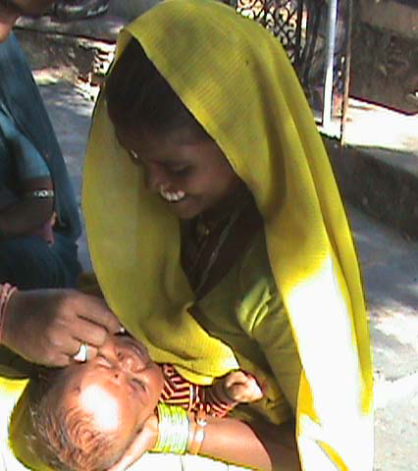
Kailashi lives with her husband Gopal Gameti in village Peepad. They both work as a laborer in a peri-urban area called Iswal, which is 10 kms from Peepad. She has a five-month old son Pawan Kumar. Pawan is her second child.
Three years ago she gave birth to her first child. When her labour pain started her husband went to fetch the traditional Birth Attendant. Her mother-in-law was also then away. Kailashi then gave birth to a little girl at home. Their little girl died on the seventh day of her birth. She simply stopped feeding one night and died the following morning. The parents did not know the reason of their child’s death nor did the Birth Attendant. The health care facilities are very far from their village and therefore the parents could not seek any care. Both Kailashi and Gopal were very sad and got scared for their future children.

However, when their second child Pawan Kumar was born Seva Mandir had started its immunization camp in Peepad. The Traditional Birth Attendant Moti bai trained by Seva Mandir, had spread the word about the camp and about the importance of immunization. Kailashi and Gopal both decided to get their second child immunized. Therefore Kailashi takes the day off from her work (it means losing a day’s wage i.e. Rs. 73) and brings her son to these Camps every month on the 7th.

